# Exercise 1: Control Structures

**Scenario 1:** The bank wants to apply a discount to loan interest rates for customers above 60 years old.

**Question:** Write a PL/SQL block that loops through all customers, checks their age, and if they are above 60, apply a 1% discount to their current loan interest rates.

CODE:

DECLARE

  v_c_id Customers.CustomerID%TYPE;

  v_dob Customers.DOB%TYPE;

  v_age **NUMBER**;

BEGIN

  FOR c_rec IN (SELECT CustomerID, DOB FROM Customers) LOOP

    v_c_id := c_rec.CustomerID;

    v_dob := c_rec.DOB;

    v_age := FLOOR(MONTHS_BETWEEN(**SYSDATE**, v_dob) / 12);

    IF v_age > 60 THEN

      UPDATE Loans

      SET InterestRate = InterestRate - 1

      WHERE CustomerID = v_c_id;

    END IF;

  END LOOP;

  DBMS_OUTPUT.PUT_LINE('Interest rate discount applied for eligible customers.');

END;

/

Output:

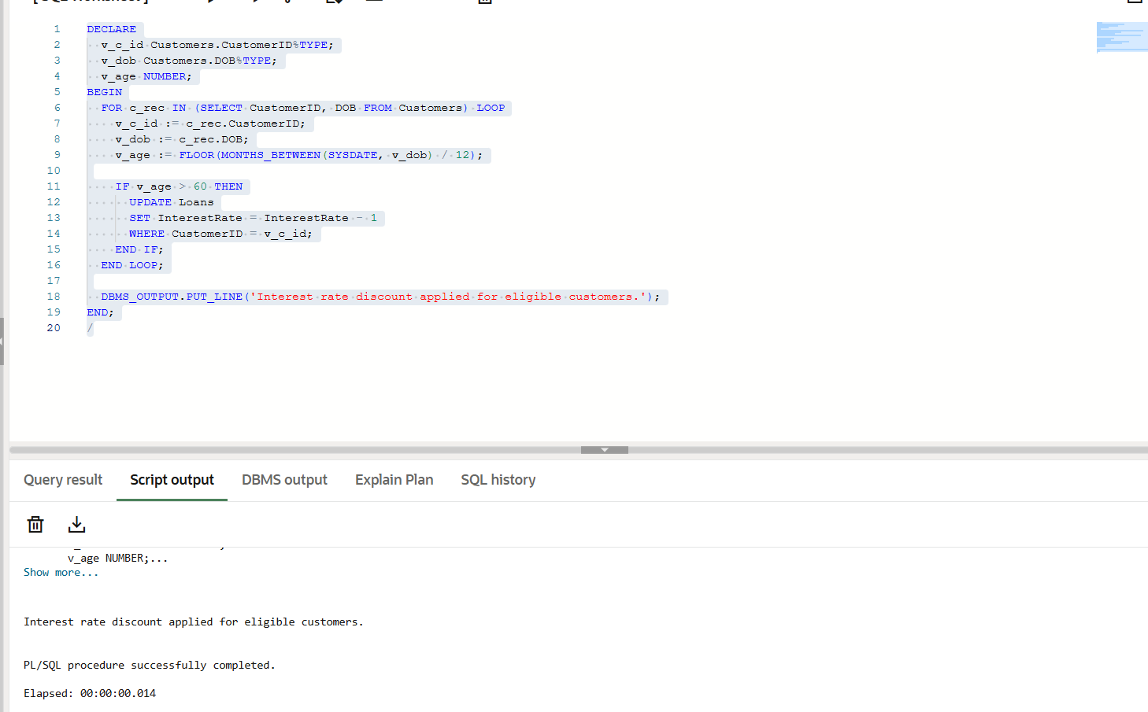

**Scenario 2:** A customer can be promoted to VIP status based on their balance.

**Question:** Write a PL/SQL block that iterates through all customers and sets a flag IsVIP to TRUE for those with a balance over $10,000.

CODE:

BEGIN

    FOR cust IN (

        SELECT CustomerID FROM Customers WHERE Balance > 10000

    ) LOOP

        UPDATE Customers

        SET IsVIP = 'TRUE'

        WHERE CustomerID = cust.CustomerID;

    END LOOP;

    COMMIT;

END;

/

Output:

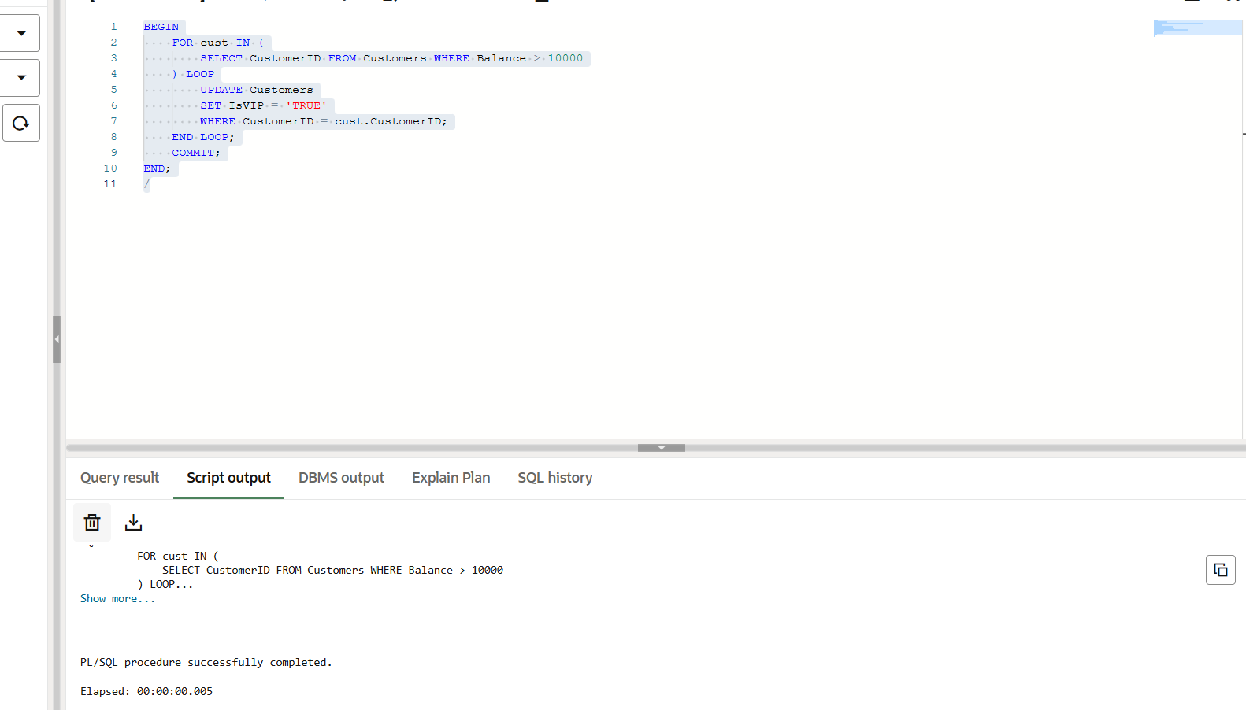

**Scenario 3:** The bank wants to send reminders to customers whose loans are due within the next 30 days.

**Question:** Write a PL/SQL block that fetches all loans due in the next 30 days and prints a reminder message for each customer.

Code:

SET SERVEROUTPUT ON;

DECLARE

    v_c_name Customers.Name%TYPE;

    v_c_id Loans.CustomerID%TYPE;

    v_l_id Loans.LoanID%TYPE;

    v_dd Loans.EndDate%TYPE;

    v_amt Loans.LoanAmount%TYPE;

    CURSOR lc IS

        SELECT LoanID, CustomerID, LoanAmount, EndDate

        FROM Loans

        WHERE EndDate BETWEEN **SYSDATE** AND **SYSDATE** + 30;

BEGIN

    FOR lr IN lc LOOP

        SELECT Name INTO v_c_name

        FROM Customers

        WHERE CustomerID = lr.CustomerID;

        v_c_id := lr.CustomerID;

        v_l_id := lr.LoanID;

        v_dd := lr.EndDate;

        v_amt := lr.LoanAmount;

        DBMS_OUTPUT.PUT_LINE('Reminder: ' || v_c_name || ', loan (ID: ' || v_l_id || ') of amount $' || v_amt || ' is due on ' || TO_CHAR(v_dd, 'DD-MM-YYYY') || '. Please pay in time.');

    END LOOP;

END;

Output:  
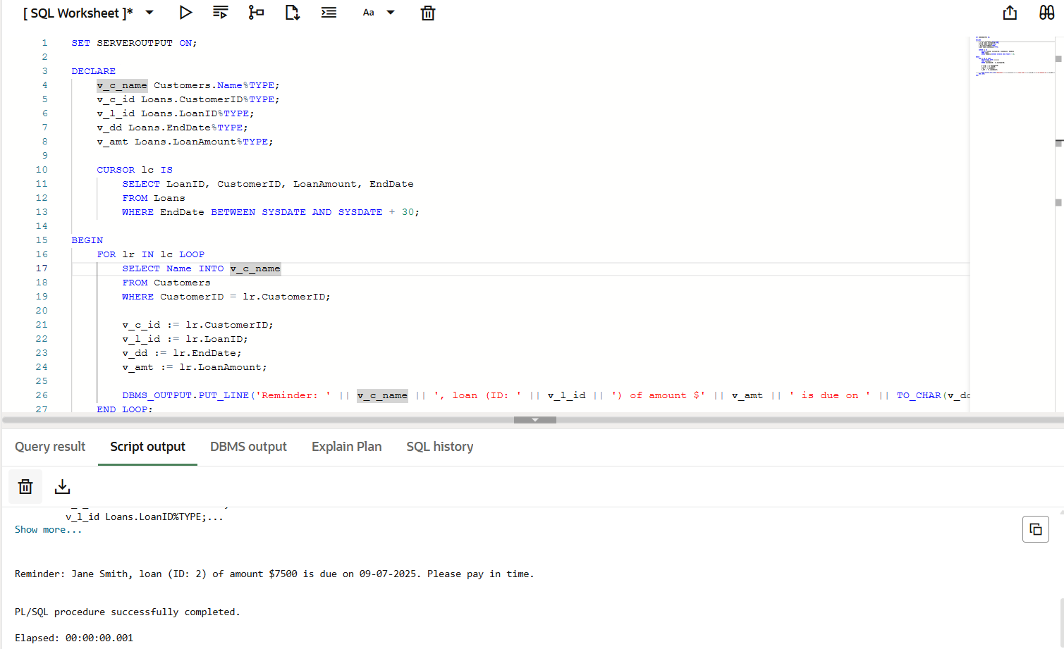

# Exercise 3: Stored Procedures

**Scenario 1:** The bank needs to process monthly interest for all savings accounts.

**Question:** Write a stored procedure **ProcessMonthlyInterest** that calculates and updates the balance of all savings accounts by applying an interest rate of 1% to the current balance.

CREATE OR REPLACE PROCEDURE ProcessMonthlyInterest AS

BEGIN

  FOR acc IN (

    SELECT AccountID, Balance

    FROM Accounts

    WHERE AccountType = 'Savings'

  ) LOOP

    UPDATE Accounts

    SET Balance = Balance + (Balance * 0.01),

        LastModified = **SYSDATE**

    WHERE AccountID = acc.AccountID;

  END LOOP;

  DBMS_OUTPUT.PUT_LINE('Monthly interest applied to all savings accounts.');

END;

/

Output:  
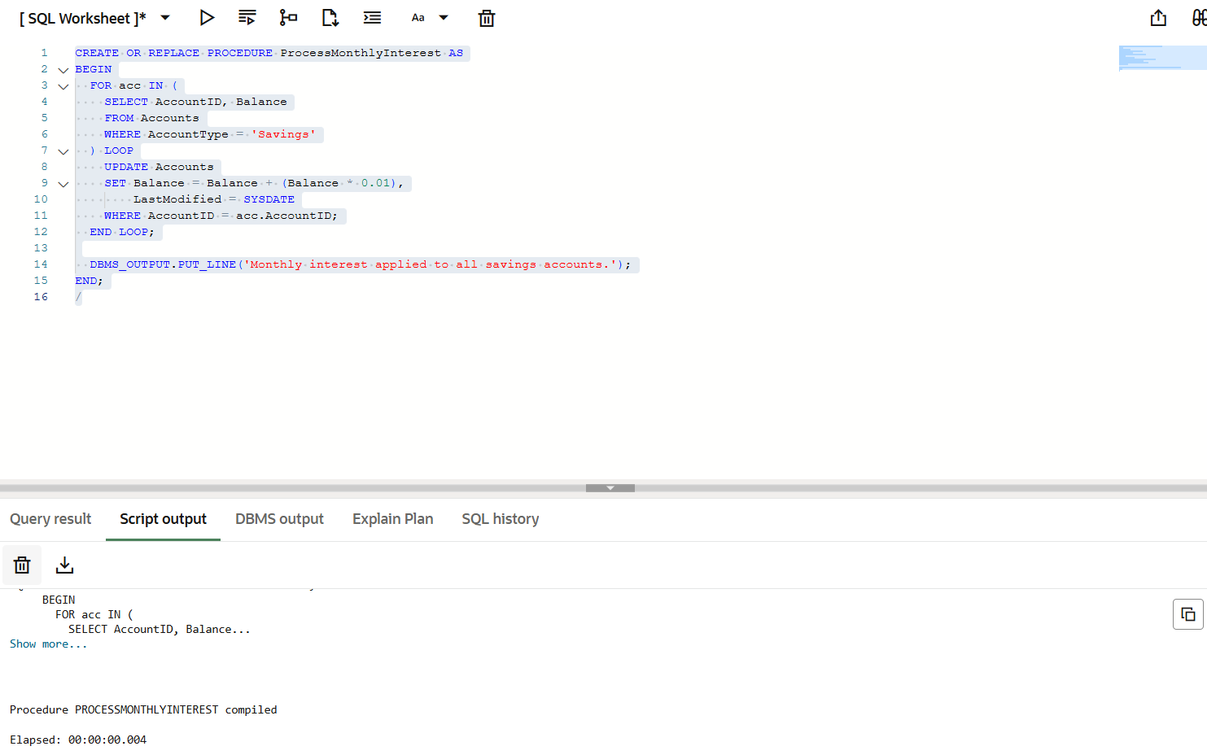

**Scenario 2:** The bank wants to implement a bonus scheme for employees based on their performance.

**Question:** Write a stored procedure **UpdateEmployeeBonus** that updates the salary of employees in a given department by adding a bonus percentage passed as a parameter.

Code:  
CREATE OR REPLACE PROCEDURE UpdateEmployeeBonus(

  p_department IN Employees.Department%TYPE,

  p_bonus_pct IN **NUMBER**

) AS

BEGIN

  UPDATE Employees

  SET Salary = Salary + (Salary * (p_bonus_pct / 100))

  WHERE Department = p_department;

  DBMS_OUTPUT.PUT_LINE('Bonus applied to department: ' || p_department);

END;

/

Output:

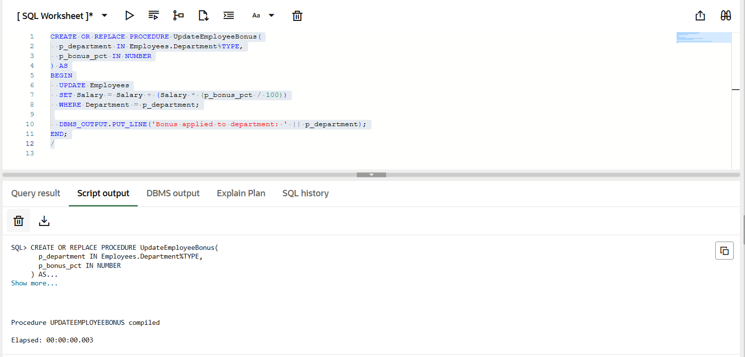

**Scenario 3:** Customers should be able to transfer funds between their accounts.

**Question:** Write a stored procedure **TransferFunds** that transfers a specified amount from one account to another, checking that the source account has sufficient balance before making the transfer.

Code:

CREATE OR REPLACE PROCEDURE TransferFunds(

  p_from_account IN Accounts.AccountID%TYPE,

  p_to_account IN Accounts.AccountID%TYPE,

  p_amount IN **NUMBER**

) AS

  v_balance **NUMBER**;

BEGIN

  SELECT Balance INTO v_balance

  FROM Accounts

  WHERE AccountID = p_from_account;

  IF v_balance < p_amount THEN

    DBMS_OUTPUT.PUT_LINE('Transfer failed: Insufficient funds.');

    RETURN;

  END IF;

  UPDATE Accounts

  SET Balance = Balance - p_amount,

      LastModified = **SYSDATE**

  WHERE AccountID = p_from_account;

  UPDATE Accounts

  SET Balance = Balance + p_amount,

      LastModified = **SYSDATE**

  WHERE AccountID = p_to_account;

  DBMS_OUTPUT.PUT_LINE('Transfer of $' || p_amount || ' completed successfully.');

END;

/

Output:  
